Creating your Weebly Site

Read each step carefully and follow all directions!

Step 1

Go to www.weebly.com

Step 2

On the right side of the page, type in the following information:

Name: We are going to make a username. Type in your first initial and last name.

Example: rweasley

Email: Weebly will never send you any emails – so we are going to make up a fake email. Your email address should be:

First Initial Last Name @ terrill.org

Example: rweasley@terrill.org

MAKE SURE YOU SPELL EVERYTHING CORRECTLY. If you make a typo now, you will not be able to log in later and will lose everything we do today.

Password: Your student ID.

MAKE SURE YOU TYPE IN YOUR CORRECT STUDENT ID.

Once you have typed in your fake email and your student ID, click “Get Started”

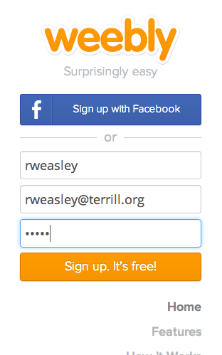

Step 3

On the next screen, click on “Free"

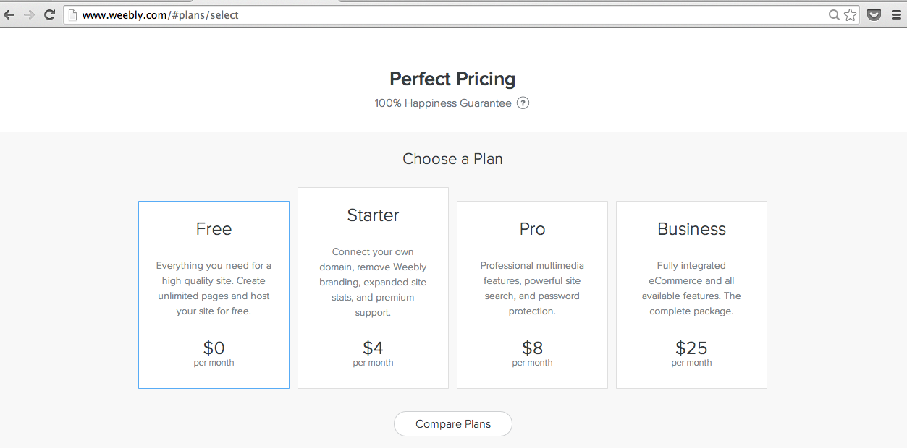

Step 4

On the next screen, when it says “What’s the Focus of Your Site?”
Click “Site”

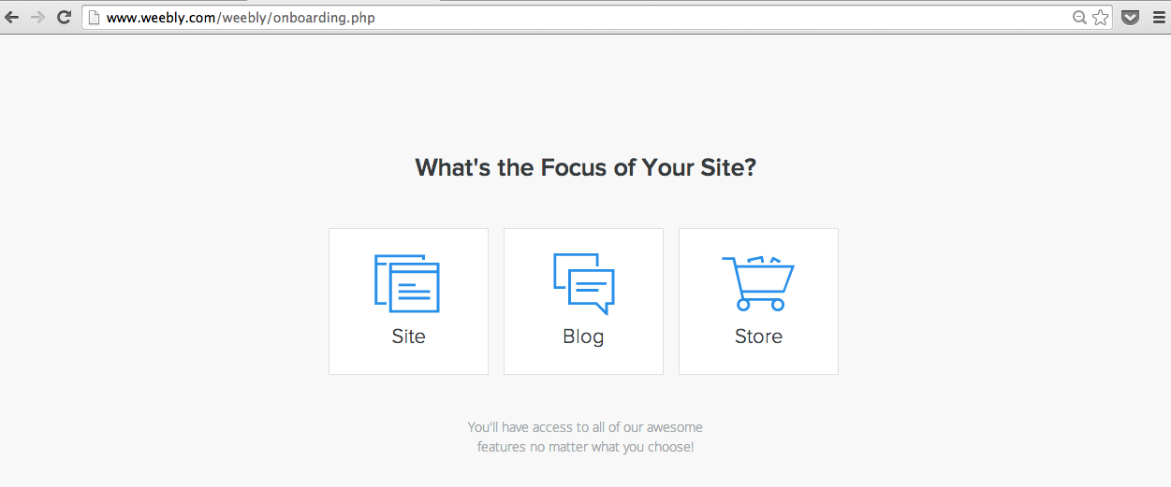

Step 5

Hover your mouse over one of the templates, select a color, and click “choose.” You can always change this later.

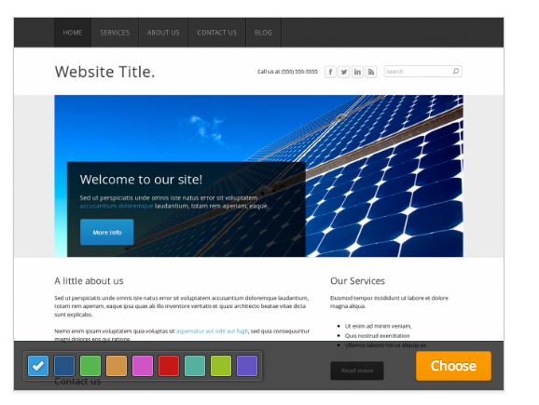

Step 5
Wait for the page to load. It will prompt you to choose your website domain. This is the web address (______.weebly.com) that visitors will use to reach your site. Select the first box “Use a Subdomain of Weebly.com” and enter your site title in the space. Example: Ron’s Writer’s Notebook or Ginny’s Blog.

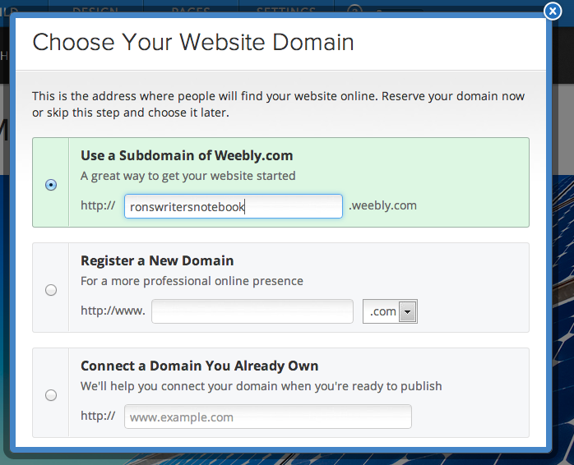

Click “continue” on the bottom right

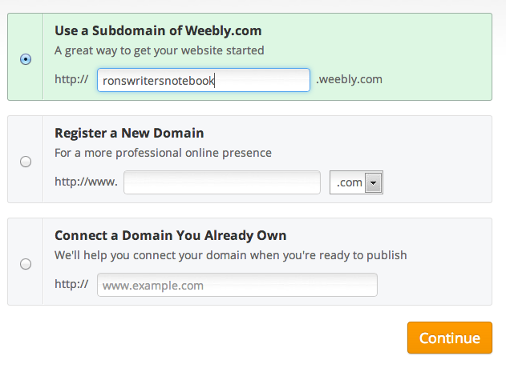

Step 6

A box will appear that reads “Welcome to Weebly!”
Click on the x in the upper right hand corner to close the box. DO NOT PLAY THE VIDEO!

Step 6

Edit your site title. This should match your site address.

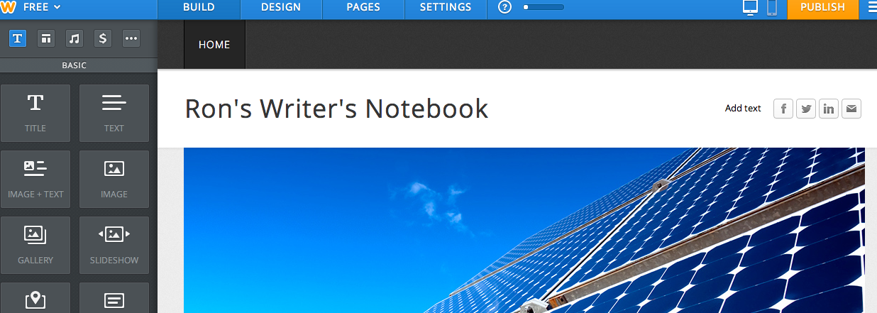

Step 7

Step 7

Edit the pages. Click on the “pages” tab on the top of the web page.

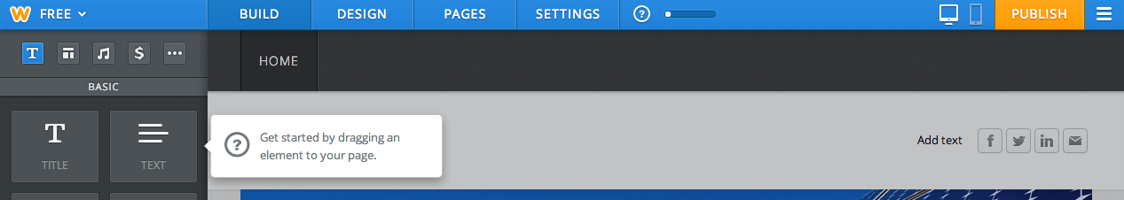

When you create your site, it has 3 pages: “Home,” “About,” and “Contact.” Keep the first and delete the second 2. To delete:
Click on the page title. Make sure it is highlighted in blue. Then click “Delete page.”
Delete the “About” page and the “Contact” page

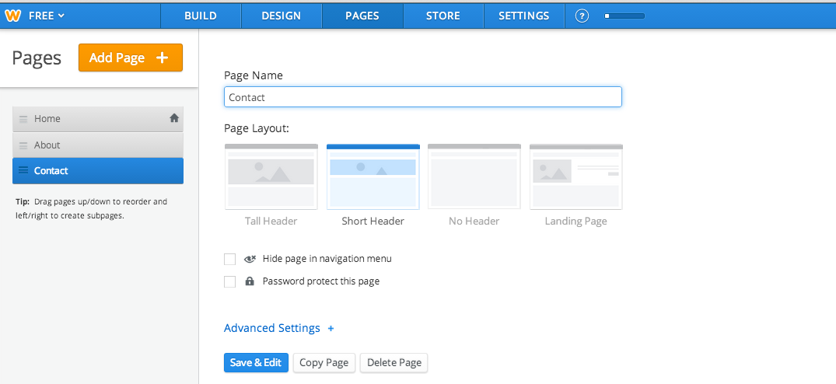

Click the “Add Page” button
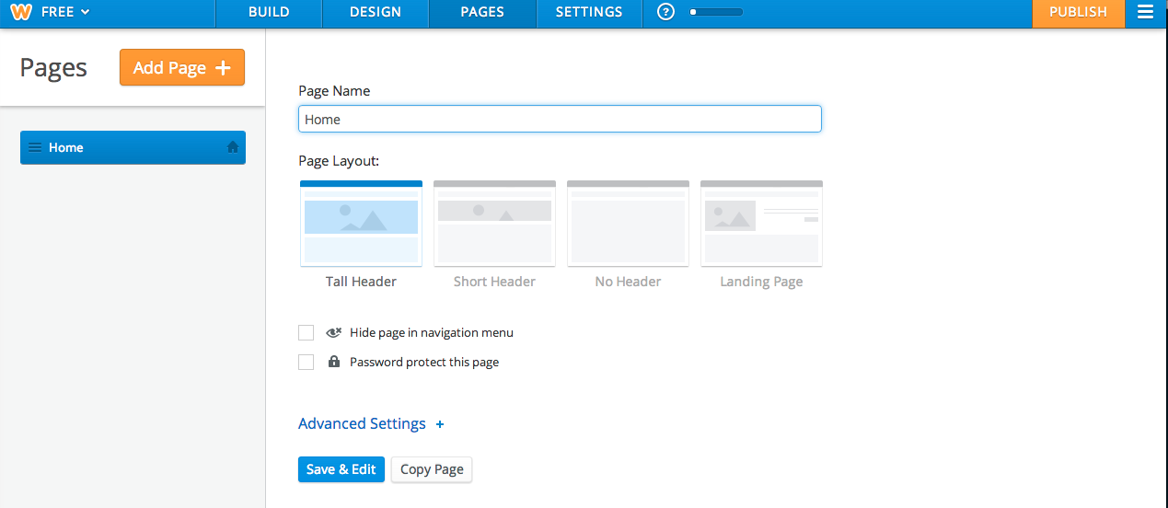

Click on “Standard Page.” Under Page Name, write “About Me.”

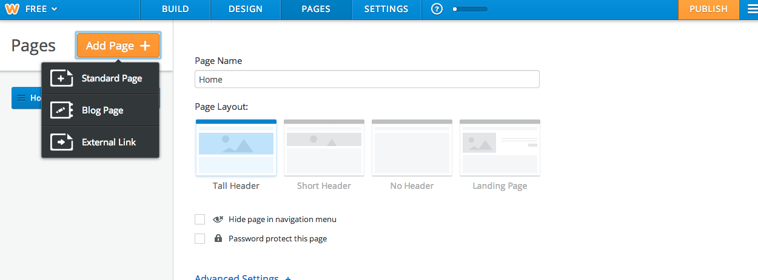

For About Me page
For Blog and E-Portfolio pages

Click on “Blog Page ” to add a blog page. Add another “Blog Page” and call it “E-Portfolio.”

Once you are done adding your pages, click “Save & Edit” on the bottom.

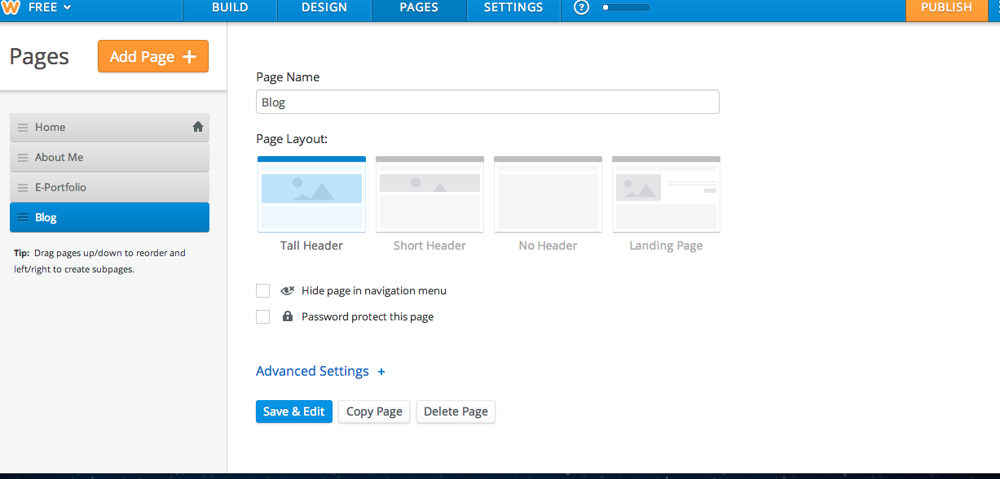

The top of your page should now look like this:
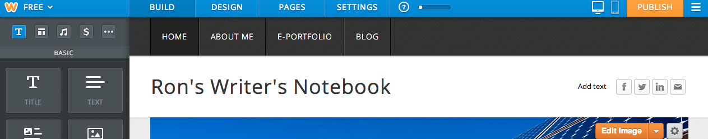

Step 8:
Click on the table for your About Me page. Create your “About Me” page. Directions and rubric are on my website under BlogBlog challenges:

http://writwork.weebly.com/creating-an-about-me-page.html

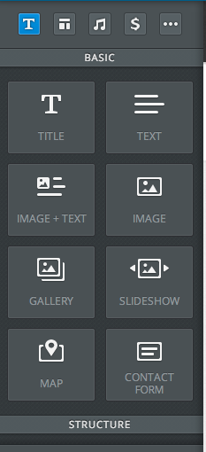
To add titles, images, and text to a page, click on the corresponding graphic on the left side of the page and drag it over onto the page you are editing.

Add text
Add a title

Step 9:
Publish your site. Click on the orange “Publish” button in the upper-right hand corner.

Step 10:
Design your website. Click on the “design” tab. Look through the design templates and choose the design you like the most.

Step 11:
Write! Pick a writer’s notebook prompt on my site or in the classroom and respond to it, either in a word document or on a post on your blog page.

